**Lab 1**

**DBMS**

**Name:** Etcherla Sai Manoj **Mis. No:** 112015044 **Branch:** CSE

**Question 1-5**

**Table Creation and Insertion of Data**

CREATE TABLE Warehouses (

Code INTEGER PRIMARY KEY NOT NULL,

Location TEXT NOT NULL ,

Capacity INTEGER NOT NULL

);

CREATE TABLE Boxes (

Code TEXT PRIMARY KEY NOT NULL,

Contents TEXT NOT NULL ,

Value REAL NOT NULL ,

Warehouse INTEGER NOT NULL,

CONSTRAINT fk_Warehouses_Code FOREIGN KEY (Warehouse) REFERENCES Warehouses(Code)

);

INSERT INTO Warehouses(Code,Location,Capacity) VALUES(1,'India',3);

INSERT INTO Warehouses(Code,Location,Capacity) VALUES(2,'India',4);

INSERT INTO Warehouses(Code,Location,Capacity) VALUES(3,'USA',7);

INSERT INTO Warehouses(Code,Location,Capacity) VALUES(4,'France',2);

INSERT INTO Warehouses(Code,Location,Capacity) VALUES(5,'JAPAN',8);

INSERT INTO Boxes(Code,Contents,Value,Warehouse) VALUES('A1A','Toys',180,3);

INSERT INTO Boxes(Code,Contents,Value,Warehouse) VALUES('B2B','Toys',250,1);

INSERT INTO Boxes(Code,Contents,Value,Warehouse) VALUES('C3C','Eatables',190,4);

INSERT INTO Boxes(Code,Contents,Value,Warehouse) VALUES('D4D','Toys',200,1);

INSERT INTO Boxes(Code,Contents,Value,Warehouse) VALUES('E5E','Dairy',75,1);

INSERT INTO Boxes(Code,Contents,Value,Warehouse) VALUES('F6F','Dairy',50,3);

INSERT INTO Boxes(Code,Contents,Value,Warehouse) VALUES('G7G','Dairy',175,2);

INSERT INTO Boxes(Code,Contents,Value,Warehouse) VALUES('H8H','Toys',140,4);

INSERT INTO Boxes(Code,Contents,Value,Warehouse) VALUES('I9I','Eatables',125,1);

INSERT INTO Boxes(Code,Contents,Value,Warehouse) VALUES('J10J','Eatables',150,2);

INSERT INTO Boxes(Code,Contents,Value,Warehouse) VALUES('K11K','Dairy',90,5);

**1)Select all boxes with a value larger than $150.**

SELECT * FROM Boxes

WHERE Value > 150;

Output:

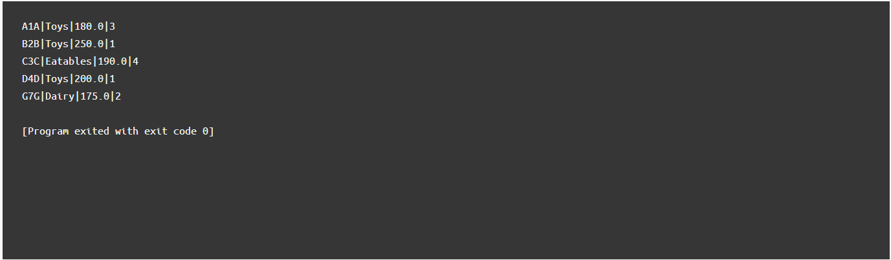

**2)** **Select the warehouse code and the average value of the boxes in each warehouse.**

SELECT Warehouse, AVG(Value)

FROM Boxes

GROUP BY Warehouse;

Output:

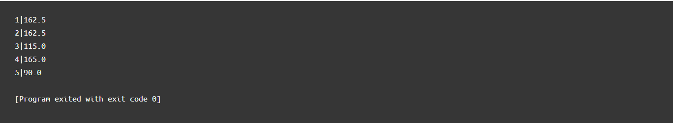

**3)Reduce the value of all boxes by 15%.**

UPDATE Boxes SET Value = Value * 0.85;

SELECT * FROM Warehouses; /*(DISPLAYING TABLE)*/

SELECT * FROM Boxes; /*(DISPLAYING TABLE)*/

Output:

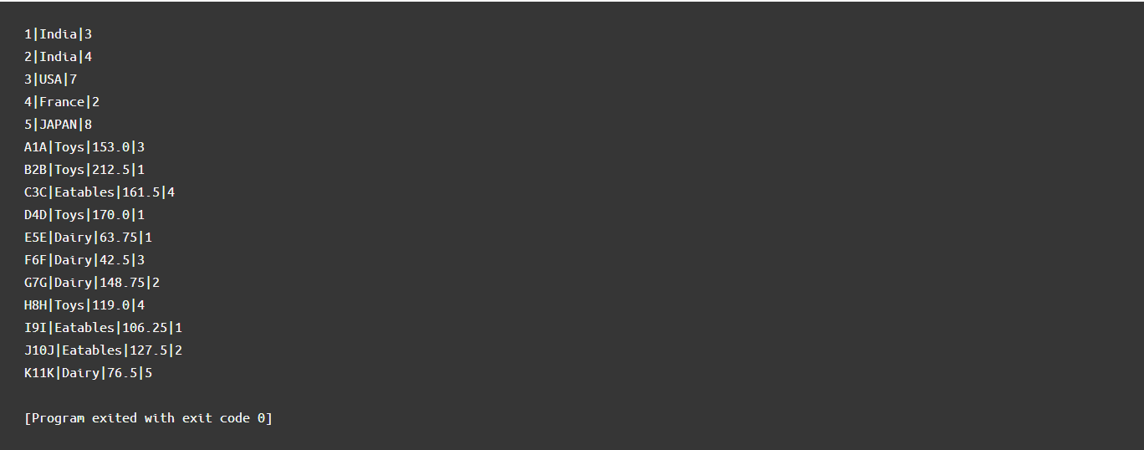

**4)Select the codes of all warehouses that are saturated (a warehouse is saturated if the number of boxes in it is larger than the warehouse's capacity).**

SELECT Code

FROM Warehouses

WHERE Capacity <

(

SELECT COUNT(*)

FROM Boxes

WHERE Warehouse = Warehouses.Code

);

Output:

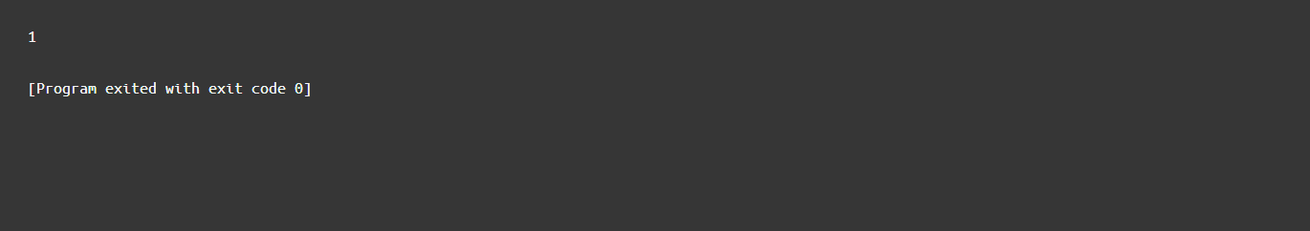

**5)Remove all boxes from saturated warehouses.**

DELETE FROM Boxes WHERE Warehouse IN

(

SELECT Code

FROM Warehouses

WHERE Capacity <

(

SELECT COUNT(*)

FROM Boxes

WHERE Warehouse = Warehouses.Code

)

);

SELECT * FROM Warehouses; /*(DISPLAYING TABLE)*/

SELECT * FROM Boxes; /*(DISPLAYING TABLE)*/

Output:

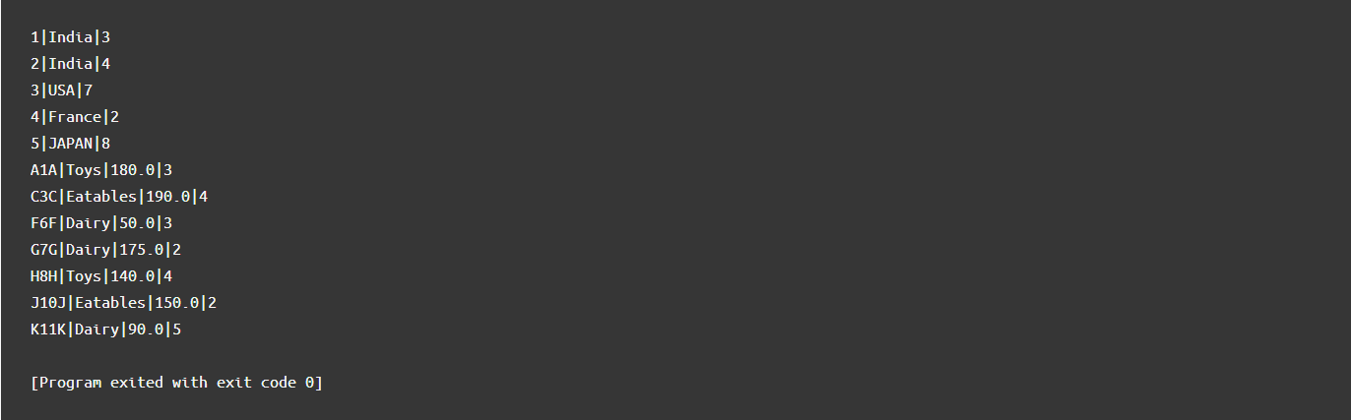

**Question 6-10**

**Table Creation and Insertion of Data**

CREATE TABLE Movies (

Code INTEGER PRIMARY KEY NOT NULL,

Title TEXT NOT NULL,

Rating TEXT

);

CREATE TABLE MovieTheaters (

Code INTEGER PRIMARY KEY NOT NULL,

Name TEXT NOT NULL,

Movie INTEGER

CONSTRAINT fk_Movies_Code REFERENCES Movies(Code)

);

INSERT INTO Movies (Code, Title, Rating) VALUES (9, 'Iron Man', 'G');

INSERT INTO Movies (Code, Title, Rating) VALUES (1, 'Captain America : First Avenger', 'PG');

INSERT INTO Movies (Code, Title, Rating) VALUES (2, 'Thor: Rangnarok', 'G');

INSERT INTO Movies (Code, Title, Rating) VALUES (3, 'The Incredible Hulk', 'G');

INSERT INTO Movies (Code, Title, Rating) VALUES (4, 'Avengers: Age of Ultron', NULL);

INSERT INTO Movies (Code, Title, Rating) VALUES (5, 'Black Widow', NULL);

INSERT INTO Movies (Code, Title, Rating) VALUES (6, 'Avengers: Infinity War', 'NC-17');

INSERT INTO Movies (Code, Title, Rating) VALUES (7, 'Avengers: End Game', 'PG-13');

INSERT INTO Movies (Code, Title, Rating) VALUES (8, 'Sherlock Holmes', NULL);

INSERT INTO MovieTheaters (Code, Name, Movie) VALUES (1, 'SVS Theatres', 5);

INSERT INTO MovieTheaters (Code, Name, Movie) VALUES (2, 'AMB Cinemas', 1);

INSERT INTO MovieTheaters (Code, Name, Movie) VALUES (3, 'Prism Theatres', NULL);

INSERT INTO MovieTheaters (Code, Name, Movie) VALUES (4, 'IMAX Cinemas', 6);

INSERT INTO MovieTheaters (Code, Name, Movie) VALUES (5, 'INOX Cinemas', 3);

INSERT INTO MovieTheaters (Code, Name, Movie) VALUES (6, 'Carnival Cinemas', NULL);

**6) Select all movie theaters that are not currently showing a movie.**

SELECT * FROM MovieTheaters WHERE Movie IS NULL;

Output:



**7) Add the unrated movie "One, Two, Three".**

INSERT INTO Movies (Code, Title, Rating) VALUES (10, 'One, Two, Three', null);

SELECT * FROM Movies; /*(DISPLAYING TABLE)*/

Output:



**8)Set the rating of all unrated movies to "G".**

UPDATE Movies SET Rating = 'G' WHERE Rating IS NULL;

SELECT * FROM Movies; /*(DISPLAYING TABLE)*/

Output:



**9) Remove movie theaters projecting movies rated "NC-17".**

DELETE FROM MovieTheaters WHERE Movie IN (SELECT Code From Movies WHERE Rating = 'NC-17');

SELECT * FROM MovieTheaters; /*(DISPLAYING TABLE)*/

Output:

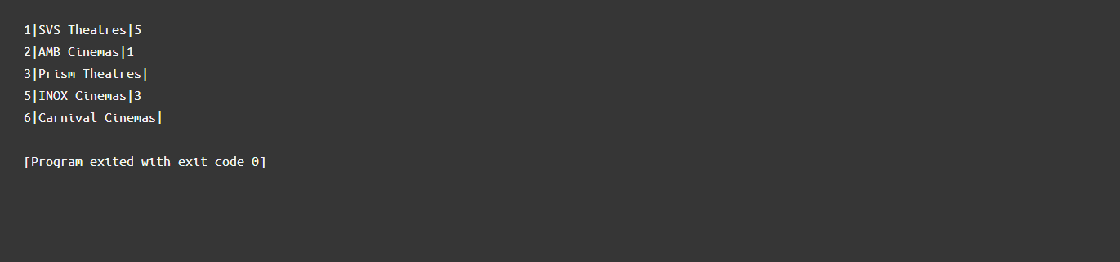

**10)Show the titles of movies not currently being shown in any theaters.**

SELECT Title FROM Movies

WHERE Code NOT IN

(

SELECT Movie FROM MovieTheaters

WHERE Movie IS NOT NULL

);

Output:

